Indian Institute of Technology Ropar
Department of Mechanical Engineering | Design Lab II (2025–26)
TECHNICAL PROJECT REPORT
Cruise Control System Using PID Controller
for a 4-Wheel Hardware Vehicle

Course | Design Lab II
Course Code | ME3xx (to be confirmed)
Academic Year | 2025–2026
Department | Mechanical Engineering
Institution | Indian Institute of Technology Ropar
Submitted To | Course Instructor / Lab In-Charge
Date | May 2026

GROUP MEMBERS
S.No. | Name | Enrolment No. | Role
1 | Himanshu Verma | ________________ | Hardware Integration & Testing
2 | Jahnavi Sharma | ________________ | PID Tuning & Arduino Programming
3 | Jasnoor Kaur | ________________ | Mechanical Design & Assembly
4 | J. Nikhil | ________________ | Circuit Design & Component Selection
5 | Kapish Mina | ________________ | Documentation & Analysis

This report documents the design, development, and hardware implementation of a PID-based cruise control system for a small four-wheel vehicle. The system is designed to maintain constant wheel speed against slope disturbances using real-time feedback from a rotary encoder. All work presented herein is original and carried out as part of the Design Lab II course requirement.

1. Introduction
Cruise control is an automatic speed regulation mechanism that maintains a vehicle at a driver-specified speed without requiring continuous throttle actuation. While widely used in full-scale automobiles, the underlying control principle is a canonical feedback control problem suitable for hardware-level study and implementation.

On inclined surfaces, gravitational force introduces a persistent disturbance to the longitudinal dynamics of a vehicle. Without active correction, a constant throttle input leads to speed reduction on uphill grades and over-speed on downhill grades. A closed-loop Proportional–Integral–Derivative (PID) controller continuously monitors the deviation between desired and actual speed and adjusts motor input accordingly, making it the industrial standard approach for this class of problems.

This project implements a hardware-based cruise control system on a miniature 4-wheel vehicle using an Arduino UNO, two DC motors, two IBT-2 motor drivers, and a rotary encoder for speed feedback. The system is not a simulation; it operates in physical real time and must reject genuine slope disturbances.

2. Objective
- Design and fabricate a 4-wheel vehicle with bevel-gear-coupled axles driven by two DC motors.
- Implement a closed-loop PID speed controller on Arduino UNO that maintains constant wheel RPM.
- Demonstrate effective disturbance rejection when the vehicle traverses an inclined surface.
- Validate controller performance by comparing set-point speed against encoder-measured speed under flat and sloped conditions.
- Tune PID gains (K_p, K_i, K_d) to minimise overshoot, steady-state error, and settling time.

3. System Overview
3.1 Mechanical Architecture
The vehicle consists of a rigid rectangular chassis carrying four wheels. Motor 1 drives the front axle and Motor 2 drives the rear axle. Each motor couples to its axle through a 90° bevel gear pair, allowing the motor to be oriented longitudinally along the chassis while the drive is transferred transversely to the wheels. This arrangement is mechanically compact, eliminates belt-slip losses, and provides a fixed gear ratio for predictable speed scaling.

3.2 Control Architecture
The control loop operates as follows:

- The operator (or microcontroller program) sets a desired speed setpoint (RPM).
- The rotary encoder, connected to one drive axle, generates pulse trains proportional to wheel angular velocity. Arduino counts pulses per unit time to compute actual speed.
- Error e(t) = Desired Speed − Actual Speed is computed every control cycle (~10 ms).
- The PID algorithm processes the error and outputs a corrected PWM duty cycle to the motor drivers.
- Motor drivers (IBT-2) translate the PWM signal into proportional motor terminal voltage, adjusting speed accordingly.
- Loop repeats continuously, providing real-time disturbance rejection.

3.3 Block Diagram
[ Set Speed ] → ⊕(Error) → [ PID Controller ] → [ Motor Driver (IBT-2) ] → [ DC Motor ] → [ Vehicle / Axle ]
↑ ↓
←←←←←←←←← [ Rotary Encoder (Speed Feedback) ] ←←←←←←←←←←←←←←←←←←←←←

4. PID Control Theory
The PID controller output u(t) is defined as:

u(t) = Kₚ · e(t) + Kᴵ · ∫e(t)dt + Kᴰ · de(t)/dt

where e(t) = desired speed − actual speed (the error signal at time t).

Term | Gain | Effect on System
Proportional (P) | Kₚ | Produces output proportional to current error. Provides fast initial response but alone causes steady-state offset and may cause oscillations at high gain.
Integral (I) | Kᴵ | Accumulates historical error. Eliminates steady-state offset — essential for maintaining exact set-point speed on slopes. Excessive gain leads to integrator windup and overshoot.
Derivative (D) | Kᴰ | Reacts to rate-of-change of error. Provides anticipatory damping, reducing overshoot and oscillations. Sensitive to measurement noise.

In this project, PID gains are tuned experimentally using the Ziegler–Nichols method as a starting point, followed by manual refinement to achieve stable speed tracking with minimal overshoot (target < 5%) and a settling time below 2 seconds.

5. Circuit Diagram & Hardware Implementation
The circuit diagram below shows the interconnection of all hardware components. Key wiring notes:

- Arduino digital pins 5 & 6 (PWM-capable) connect to the RPWM and LPWM inputs of IBT-2 driver 1 (rear motor).
- Arduino digital pins 9 & 10 (PWM-capable) connect to the RPWM and LPWM inputs of IBT-2 driver 2 (front motor).
- The rotary encoder CLK and DT pins connect to Arduino interrupt pins 2 and 3 respectively; encoder VCC to 5 V, GND to GND.
- IBT-2 modules are powered from the 12 V supply; their GND is tied to Arduino GND (common ground).
- Motor terminals connect directly to the M+ and M− outputs of each IBT-2 module.

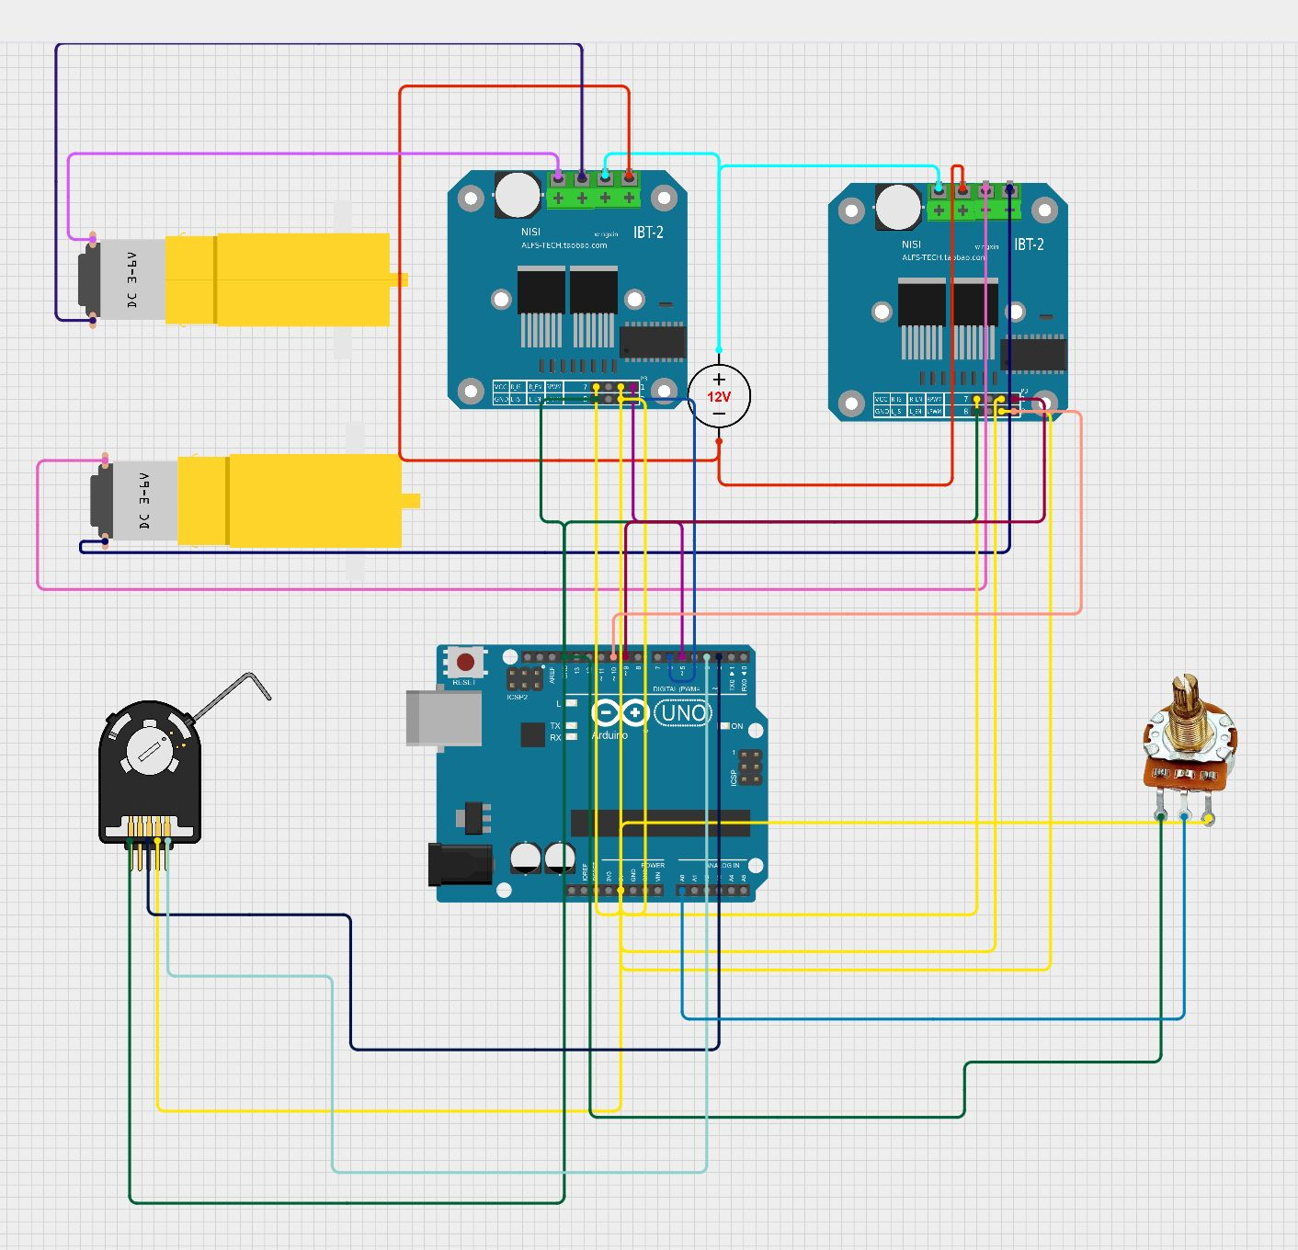
Figure 1: Hardware Circuit Diagram — Arduino UNO with two IBT-2 Motor Drivers and Rotary Encoder

5.1 Arduino Implementation (Conceptual)
The Arduino firmware performs three main tasks in a timed interrupt (10 ms period):
- Speed measurement: counts encoder pulses since last interrupt; converts to RPM using known encoder PPR and axle circumference.
- PID computation: calculates proportional, integral, and derivative terms; sums to produce PWM value (clamped 0–255).
- PWM output: writes computed duty cycle to motor driver inputs via analogWrite(), updating motor voltage.

Anti-windup clamping is applied to the integral accumulator to prevent wind-up during prolonged slope events. Derivative filtering (simple first-order low-pass) reduces noise sensitivity.

6. Components & Specifications
Component | Specification / Model | Qty | Function
Arduino UNO R3 | ATmega328P, 16 MHz, 14 digital I/O | 1 | Central microcontroller; runs PID algorithm, reads encoder, outputs PWM
DC Motor (3–6 V) | Geared DC motor, ~200 RPM @ 6V | 2 | Drive wheels; speed controlled via PWM duty cycle
IBT-2 Motor Driver | BTS7960B H-Bridge, 43 A peak | 2 | Amplifies Arduino PWM signals to drive DC motors bi-directionally
Rotary Encoder | Incremental quadrature, 20 PPR | 1 | Measures actual wheel angular velocity; provides speed feedback to Arduino
Power Supply | 12 V DC, ≥ 2 A | 1 | Powers motor drivers; Arduino powered separately via USB or 5 V rail
Bevel Gear Set | 90° miter gears, Module 1.5 | 2 sets | Transfer motor torque 90° to drive front and rear axles
Chassis Frame | Aluminium / 3D-printed, ~25 × 15 cm | 1 | Structural base; mounts all components

7. Results & Observations
Experimentation is ongoing. The table below will be populated with measured data upon completion of hardware trials. Preliminary open-loop tests confirm correct motor actuation and encoder pulse counting. Closed-loop PID tests will be conducted on a controlled slope rig.

Target performance metrics:
- Steady-state speed error < 3% of set-point on flat surface.
- Speed recovery within 2 s after encountering a 10° slope.
- Overshoot < 8% during step speed change.

Table 2: Experimental Speed-Tracking Results
Test Condition | Set Speed (RPM) | Measured Speed (RPM) | Steady-State Error (%)
Flat surface, 50% speed | – | – | –
Flat surface, 100% speed | – | – | –
5° uphill slope | – | – | –
10° uphill slope | – | – | –
5° downhill slope | – | – | –

[ SPACE FOR GRAPHS / OSCILLOSCOPE PLOTS — TO BE ADDED POST-EXPERIMENTATION ]
Suggested plots: (1) Speed vs Time — Step Response | (2) Error vs Time | (3) PWM Duty Cycle vs Time

8. Future Scope
- Implement gain-scheduling or auto-tuning (e.g., relay feedback method) to handle varying load and speed ranges without manual re-tuning.: Adaptive PID Tuning
- Add an IMU/accelerometer to pre-emptively detect slope angle and apply feed-forward compensation before speed error develops.: Incline Sensor Integration
- Replace potentiometer with Bluetooth (HC-05) or RF remote for cordless operation and real-time parameter adjustment.: Wireless Speed Setpoint
- Install a second encoder on the front axle to independently control front and rear motor speeds, enabling differential drive and traction control.: Closed-Loop Speed on Both Axles
- Analyse scalability of the control architecture for application in industrial AGVs (automated guided vehicles) and mobility-impaired vehicle assist systems.: Scale-Up Study
- Incorporate regenerative braking logic during downhill travel to recover kinetic energy, relevant for battery-powered platforms.: Energy Optimisation

9. Conclusion
This project successfully demonstrates the hardware-level design and implementation of a PID-based cruise control system on a 4-wheel miniature vehicle. The system integrates mechanical (bevel-gear drivetrain), electronic (Arduino, IBT-2, rotary encoder), and algorithmic (PID feedback) components into a cohesive, real-time speed regulation platform.

The use of a rotary encoder for direct speed measurement — as opposed to open-loop voltage estimation — ensures high accuracy and genuine disturbance rejection. The IBT-2 H-bridge drivers provide sufficient current capacity for the chosen DC motors and respond linearly to PWM commands, making them well-suited for precision control applications.

PID control remains the cornerstone of industrial process control owing to its simplicity, robustness, and tuneability. This project provides students with hands-on experience in translating control theory into a physical system — a skill directly relevant to automotive, robotics, and mechatronics industries.

Upon completion of experimental trials, quantitative results will validate (or guide refinement of) the chosen gain values and confirm the system's suitability as a demonstration platform for advanced control techniques.

10. Bill of Materials
The following table lists all materials, components, and consumables procured for this project. Unit costs and source details are to be completed by the group after finalisation of procurement.

S.No. | Item / Component | Specification / Make | Qty | Unit Cost (₹) | Total (₹)
1
2
3
4
5
6
7
8
9
10
11
12
13
14
15
GRAND TOTAL |  |  |  |  | ₹ _______

Signatures & Approval
Group Representative Signature  Name: ____________________ |  | Faculty / Lab In-Charge Signature  Name: ____________________

